Purchasing an Ad/Vendor Table for the
16th Annual Brotherhood of Men Conference.

Conference Dates:
Thursday, October 23rd through Saturday, October 25th, 2025
​
This is a great opportunity to advertise your upcoming events and showcase your items for purchase or give as information of your congregation or personal business.
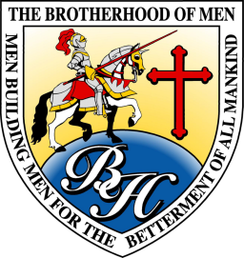

www.ewhiteministries.com
Full-page color Ad: $150

The pages will be 8.5 inches wide X 11 inches high, and your ad should be submitted electronically in high resolution as a JPEG or PDF.
​​

Half-page color Ad: $100

The pages will be 8.5 inches wide X 5.5 inches high, and your ad should be submitted electronically and high resolution as a JPEG or PDF.

Vendor Table: $100

If you would like to sell items at the conference, you may purchase a vendor table. All vendor’s tables will be approved within 2 weeks of purchase. Information only Vendor Table is no charge.

_______________________________________________________________
Please Print Clearly
Your Name:________________________________________
Credit Card: (Please call to use credit card for purchase), mail a payable check to: E. White Ministries, 3515 Sycamore School Road, Suite 125-PMB 184, Fort Worth, Texas 76133, or click this link to purchase:
https://docs.google.com/forms/d/e/1FAIpQLSfiE0JwfDtvMw7vtMrIxKsIZcvTScdA2LLOJf1Y_Uk_-JXTEg/viewform?usp=dialog
Business or Church name on the Credit Card: ___________________________________________________________________________
Email Address__________________________________
Contact Phone #_______________________________________
For questions, please call or text 806-239-9229.

