Purchasing an ad for the
16th Annual Brotherhood of Men Conference.

Conference Dates:
Thursday, October 23rd through Saturday, October 25th, 2025
​

This is a great opportunity to advertise your upcoming events for your congregation or personal business.

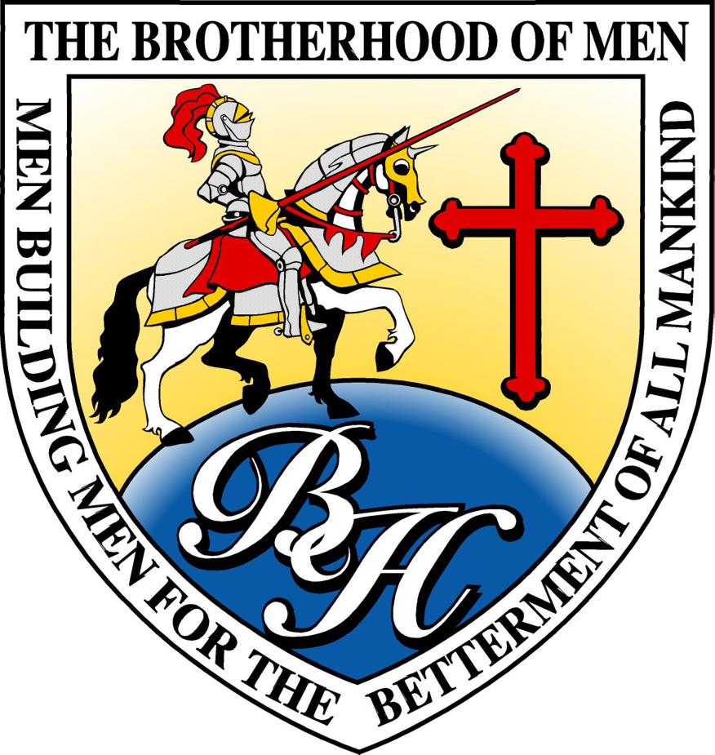

www.ewhiteministries.com

Full page color Ad: $150

The pages will be 8.5 inches width X 11 inches height, and your ad should be submitted electronically and high resolution as a jpeg or pdf.
​​

Half Full-page color Ad: $100

The pages will be 8.5 inches width X 5.5 inches height, and your ad should be submitted electronically and high resolution as a jpeg or pdf.

For questions or vendor tables, please call or text 806-239-9229.

