**CONFERENCE MEMORABILIA**

Shirt and Cap colors will change each year.

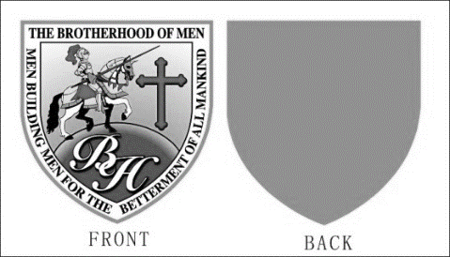

**DEADLINE TO ORDER SEPTEMBER 22nd, 2024**

**Polo Shirts $32 each**

**Add $3 more for each additional “X” size**

**LAPEL PINS**

**$8.00 EACH**

**CAPS**

**$25 EACH**

**(Only limited sizes will be sold at the conference)**

**Quantity and Sizes (circle one)**

**$32 SM**

**$32 MED**

**$32 LG**

**$35 XL**

**$35 1X**

**$38 2X**

**$41 3X**

**$44 4X**

**Scan me**

**PLEASE SCAN QR CODE TO ORDER----WWW.EWHITEMINISTRIES.COM**

**Additional information call or text: 806-239-9229**