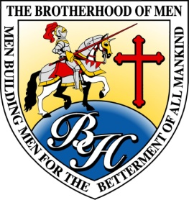
Brotherhood of Men
2019 Information Sheet

Conference Dates: OCTOBER 24th to October 26th (Thursday through Saturday)
Kickoff Time, Thursday, 6:00 p.m.

Location: The DFW Airport Marriott Hotel-South
4151 Centreport Blvd.
Fort Worth, TX 76155
Call: 817-358-1700 or 1-800-228-9290 for reservations
Book your group rate for The Brotherhood of Men Conference

Hotel Cost: Reserved Room block under “Brotherhood of Men”
$120 per night for a single king room with free breakfast buffet on Friday and Saturday
$120 per night for a double queen room with free breakfast buffet on Friday and Saturday

Hotel Amenities: Free Parking

Theme: “NEXT LEVEL MANHOOD”

Speakers: Alvin Daniels, Jr., Miami, Florida
Dr. Harold Redd, Nashville, Tennessee
Don McLaughlin, Atlanta, Georgia
Thomas L. Thomas, Freeport, New York
Emanuel White, Sr., Fort Worth, TX

Conference Website: www.ewhiteministries.com

Mailing Address: 3515 Sycamore School Road, Suite 125-PMB 184, Fort Worth, Texas 76133

Contact Info: Doris Henderson, Coordinator 817-453-4015 or Fax 817-453-4021, or email: ewhiteministries@att.net
Emanuel White, Sr. 817-929-9044 or email: ewhite1122@sbcglobal.net

Buddy Pass Special You pay $165 and your buddy pays $125.00, deadline, Monday, September 30th, 2019

Regular Registration $165 per person, from Tuesday, October 1st, to Tuesday, October 15th, NO EXCEPTIONS

Late Registration $185 per person after October 15TH until the conference kickoff on October 24th,
NO EXCEPTIONS

Registration Includes: Complimentary Meet and Greet hors d'oeuvre, Thursday evening @ 5:00 p.m. Complimentary coffee and water in all conference sessions
Complimentary lunch on Friday
8 conference sessions
Complimentary conference bag, ball point pen, booklet, and more.

